
US INDUSTRY STATE REPORT FL48831
Port & Harbor Operations in Florida
March 2026



State Industry Report

Industry Performance

Establishments
The number of Port & Harbor Operations establishments in Florida accounts for 10.9% of the 331 establishments within the national industry, ranking Florida 1st for the number of industry establishments within the US.
Port & Harbor Operations in Florida #1 in Highest Establishments  36 Establishments (2026) -1.1% Annual Growth (2021-26) 1.6% Annual Growth (2026-31) |  | Port & Harbor Operations in the US  331 Establishments (2026) -1.1% Annual Growth (2021-26) 0.9% Annual Growth (2026-31)

Revenue
Port & Harbor Operations in Florida contributes 3.9% to the total national industry's revenue of $6.0 billion, ranking Florida 8th out of 45 states in total industry revenue.
Port & Harbor Operations in Florida #8 in Highest Revenue 3.9% of state's GDP  $237.6m Revenue (2026) 3.8% Annual Growth (2021-26) 2.3% Annual Growth (2026-31) |  | Port & Harbor Operations in the US  $6.0bn Revenue (2026) 3.6% Annual Growth (2021-26) 2.7% Annual Growth (2026-31)

Employment
Employment for Port & Harbor Operations in Florida totals an estimated 1,770 which increased an annualized 3.8% over the past five years. Florida employs the 2nd-most employees nationwide.
Port & Harbor Operations in Florida #2 in Most Employment  1,770 Employment (2026) 3.8% Annual Growth (2021-26) 2.4% Annual Growth (2026-31) |  | Port & Harbor Operations in the US  15,046 Employment (2026) 3.5% Annual Growth (2021-26) 2.4% Annual Growth (2026-31)

Wages
Total wages for Port & Harbor Operations in Florida amount to $81.9 million, which increased an annualized 3% over the past five years. The average wage of Port & Harbor Operations employees in Florida is $46,266, which is 43% lower than the industry's national average wage of $81,158.
Port & Harbor Operations in Florida #5 in Highest Wages  $81.9m Wages (2026) 3.0% Annual Growth (2021-26) 2.7% Annual Growth (2026-31) |  | Port & Harbor Operations in the US  $1.2bn Wages (2026) 2.5% Annual Growth (2021-26) 2.5% Annual Growth (2026-31)

Current Performance & Outlook | The Port & Harbor Operations industry in Florida is expected to grow an annualized 3.8% to $237.6 million over the five years to 2026, while the national industry will likely grow at 3.6% during the same period. Industry establishments decreased an annualized -1.1% to 36 locations. Industry employment has increased an annualized 3.8% to 1,770 workers, while industry wages have increased an annualized 3% to $81.9 million.  Over the five years to 2031, the industry is expected to grow an annualized 2.3% to $265.7 million, while the national industry is expected to grow 2.7%. Industry establishments are forecast to grow 1.6% to 39 locations. Industry employment is expected to increase an annualized 2.4% to 1,996 workers, while industry wages are forecast to increase 3% to $93.5 million.
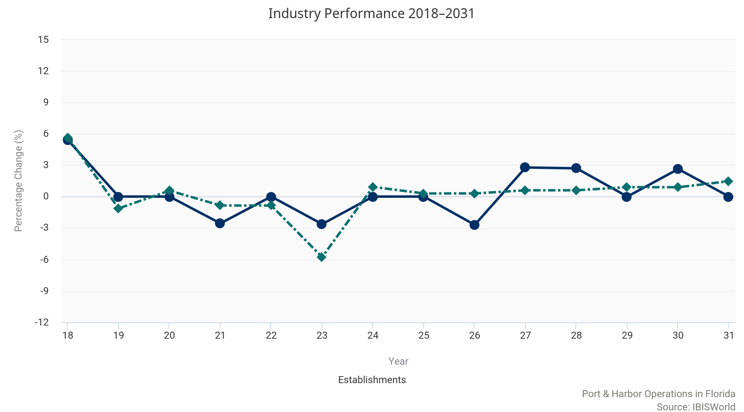
Port & Harbor Operations in Florida

Port & Harbor Operations in the US

Key External Drivers | Every industry encounters external factors that impact industry performance. In addition to the three most influential national key external drivers of an industry, we have identified key state level indicators that are likely to impact the local industry's performance.

Florida Economic Indicators  2.0% Population 17.2% Unemployment Rate 6.4% Median Houshold Income  View more state economic information in the FL State Economic Profile. |  | US Key External Drivers  0.5% Total trade value 2.1% Consumer spending 3.8% Freight transportation services index
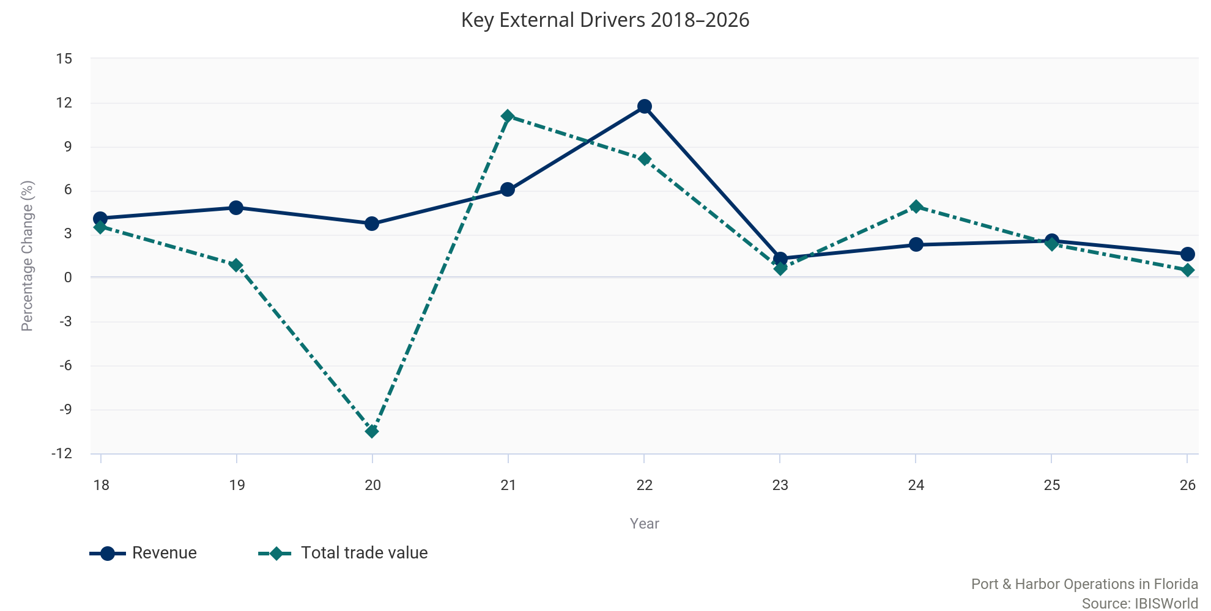

County Industry Data

Miami-Dade County  8 Est.  Most Establishments | Duval County  $87.8m  Highest Revenue | Volusia County  141.0%  Fastest Growing | Hillsborough County  -9.6%  Slowest Growing | Duval County  $122.5k  Highest Average Wage | Miami-Dade County  364 Employees  Most Employees

Establishments
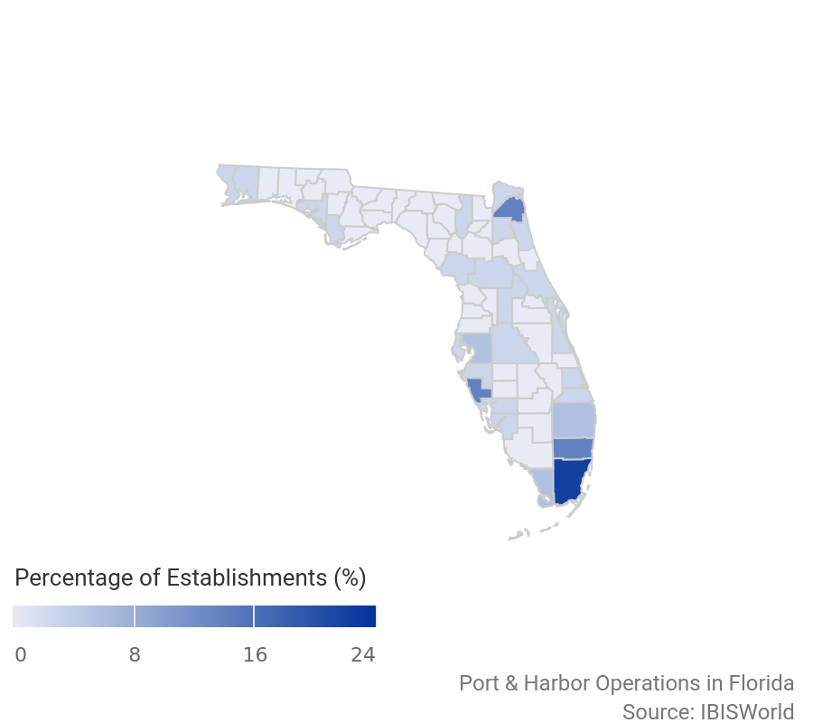 | County Establishments Annual Growth Rate (2025-26) Share of State  Miami-Dade County 8 33.3% 22.2%  Broward County 5 0.0% 13.9%  Duval County 5 0.0% 13.9%  Sarasota County 5 -28.6% 13.9%  Hillsborough County 2 -33.3% 5.6%  Monroe County 2 0.0% 5.6%  Palm Beach County 2 -33.3% 5.6%  Bay County 1 0.0% 2.8%  Brevard County 1 0.0% 2.8%  Charlotte County 1 0.0% 2.8%  The largest distribution of industry establishments in Florida is concentrated in Miami-Dade County. Miami-Dade County accounts for 22.2% of the total establishments within the state.

The top 10 counties by highest establishments are displayed in the PDF version of this report. You can view insights for all counties associated with this industry on my.ibisworld.com.

Revenue
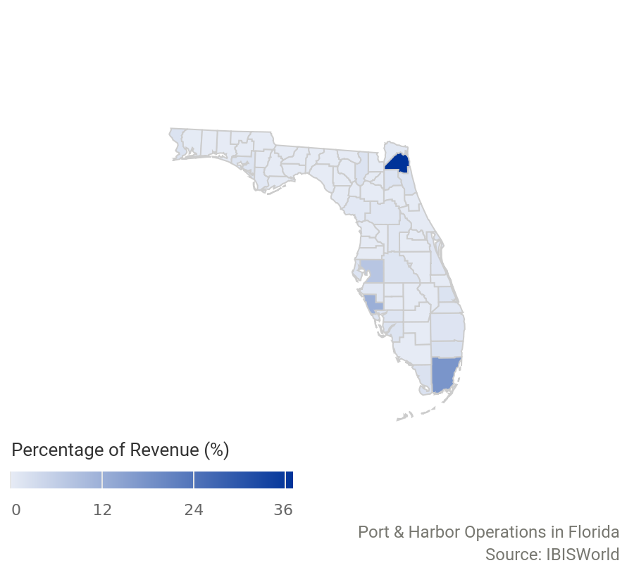 | County Revenue $ Annual Growth Rate (2025-26) Share of State  Duval County 87.8m 0.9% 36.9%  Miami-Dade County 41.3m 4.8% 17.4%  Sarasota County 28.5m -6.0% 12.0%  Hillsborough County 18.1m -9.6% 7.6%  Broward County 4.8m 2.3% 2.0%  Monroe County 4.3m 14.9% 1.8%  St. Lucie County 4.0m -4.0% 1.7%  Escambia County 4.0m 3.2% 1.7%  Columbia County 3.9m 1.4% 1.6%  Lee County 3.5m 11.2% 1.5%  Duval County contributes most to the state industry's total revenue, with 36.9% of state revenue coming from the county.

The top 10 counties by highest revenue are displayed in the PDF version of this report. You can view insights for all counties associated with this industry on my.ibisworld.com.

Employment
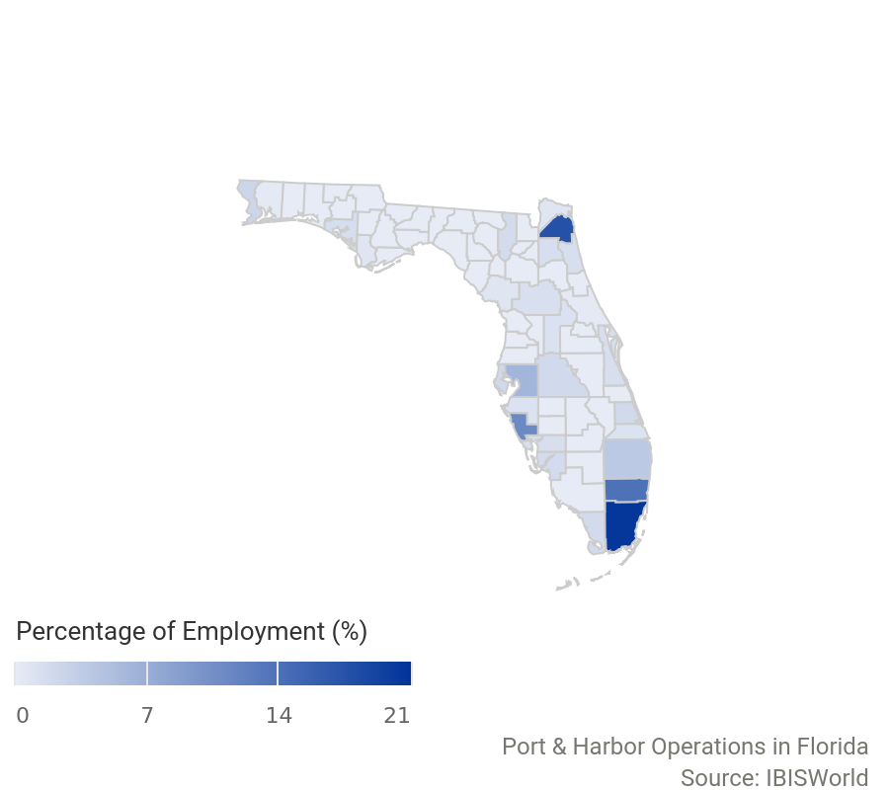 | County Employment Annual Growth Rate (2025-26) Share of State  Miami-Dade County 364 32.4% 20.6%  Duval County 312 -3.1% 17.6%  Broward County 245 12.4% 13.8%  Sarasota County 197 -23.3% 11.1%  Hillsborough County 110 -29.9% 6.2%  Palm Beach County 69 -16.9% 3.9%  Escambia County 43 7.5% 2.4%  Pinellas County 36 50.0% 2.0%  Polk County 34 41.7% 1.9%  St. Lucie County 34 -20.9% 1.9%  The largest number of industry employees in Florida is concentrated in Miami-Dade County. Miami-Dade County employs 364 individuals - 20.6% of all state industry employees.

The top 10 counties by highest employment are displayed in the PDF version of this report. You can view insights for all counties associated with this industry on my.ibisworld.com.

Wages
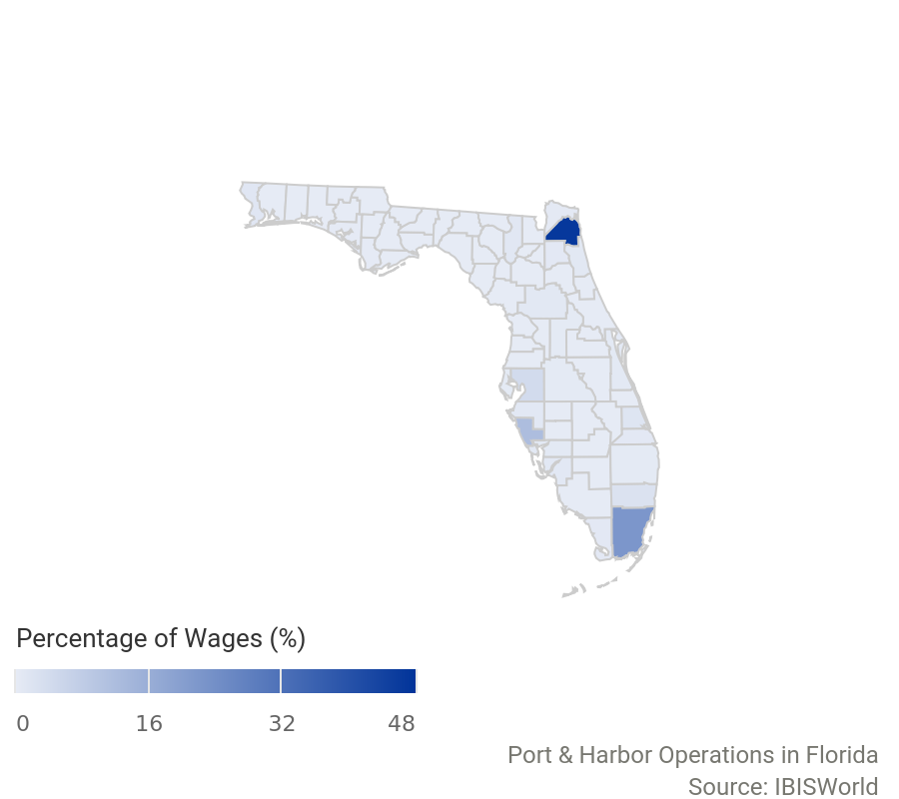 | County Wages $ Annual Growth Rate (2025-26) Share of State  Duval County 38.2m -17.6% 46.7%  Miami-Dade County 18.1m 451.3% 22.1%  Sarasota County 9.7m -15.6% 11.9%  Hillsborough County 3.5m -14.2% 4.2%  Broward County 2.0m -15.6% 2.4%  St. Lucie County 1.3m -16.3% 1.6%  Escambia County 971.9k -13.4% 1.2%  Columbia County 873.6k -15.0% 1.1%  Marion County 650.1k -13.8% 0.8%  St. Johns County 647.4k -14.6% 0.8%  Duval County has spent the most on total wages within Florida, with 46.7% of the state's total wages coming from the county.

The top 10 counties by highest wages are displayed in the PDF version of this report. You can view insights for all counties associated with this industry on my.ibisworld.com.

Key Statistics

State Industry Data
Year | Revenue  ($m) | Establishments  (Units) | Enterprises  (Units) | Employment  (Units) | Wages  ($m)
2007 | 71.9 | 23.0 | 20.0 | 754 | 29.8
2008 | 80.6 | 29.0 | 27.0 | 643 | 25.5
2009 | 103 | 28.0 | 26.0 | 584 | 22.2
2010 | 105 | 31.0 | 27.0 | 550 | 25.7
2011 | 112 | 27.0 | 24.0 | 559 | 26.6
2012 | 130 | 60.0 | 47.0 | 2,958 | 122
2013 | 142 | 42.0 | 38.0 | 804 | 35.8
2014 | 146 | 38.0 | 34.0 | 775 | 33.5
2015 | 158 | 37.0 | 34.0 | 899 | 36.0
2016 | 157 | 37.0 | 34.0 | 917 | 34.9
2017 | 164 | 37.0 | 32.0 | 1,034 | 41.6
2018 | 171 | 39.0 | 33.0 | 1,281 | 60.4
2019 | 179 | 39.0 | 33.0 | 1,452 | 65.7
2020 | 186 | 39.0 | 34.0 | 1,435 | 66.0
2021 | 197 | 38.0 | 32.0 | 1,469 | 70.8
2022 | 220 | 38.0 | 33.0 | 1,549 | 72.6
2023 | 223 | 37.0 | 33.0 | 1,619 | 74.9
2024 | 228 | 37.0 | 33.0 | 1,675 | 77.3
2025 | 234 | 37.0 | 33.0 | 1,733 | 79.9
2026 | 238 | 36.0 | 33.0 | 1,770 | 81.9
2027 | 243 | 37.0 | 33.0 | 1,812 | 84.0
2028 | 248 | 38.0 | 32.0 | 1,856 | 86.0
2029 | 254 | 38.0 | 32.0 | 1,902 | 88.8
2030 | 260 | 39.0 | 33.0 | 1,948 | 91.1

Annual Change
Year | Revenue  (%) | Establishments  (%) | Enterprises  (%) | Employment  (%) | Wages  (%)
2008 | 12.0 | 26.1 | 35.0 | -14.7 | -14.7
2009 | 27.6 | -3.45 | -3.70 | -9.18 | -12.6
2010 | 2.28 | 10.7 | 3.85 | -5.82 | 15.4
2011 | 6.14 | -12.9 | -11.1 | 1.64 | 3.52
2012 | 16.3 | 122 | 95.8 | 429 | 358
2013 | 9.08 | -30.0 | -19.1 | -72.8 | -70.6
2014 | 3.04 | -9.52 | -10.5 | -3.61 | -6.29
2015 | 8.18 | -2.63 | 0.00 | 16.0 | 7.46
2016 | -0.27 | 0.00 | 0.00 | 2.00 | -2.97
2017 | 4.34 | 0.00 | -5.88 | 12.8 | 19.0
2018 | 4.09 | 5.41 | 3.13 | 23.9 | 45.1
2019 | 4.81 | 0.00 | 0.00 | 13.3 | 8.85
2020 | 3.72 | 0.00 | 3.03 | -1.17 | 0.38
2021 | 6.02 | -2.56 | -5.88 | 2.37 | 7.29
2022 | 11.7 | 0.00 | 3.13 | 5.45 | 2.58
2023 | 1.33 | -2.63 | 0.00 | 4.52 | 3.14
2024 | 2.26 | 0.00 | 0.00 | 3.46 | 3.26
2025 | 2.54 | 0.00 | 0.00 | 3.46 | 3.28
2026 | 1.64 | -2.70 | 0.00 | 2.14 | 2.54
2027 | 2.26 | 2.78 | 0.00 | 2.37 | 2.55
2028 | 2.21 | 2.70 | -3.03 | 2.43 | 2.42
2029 | 2.19 | 0.00 | 0.00 | 2.48 | 3.21
2030 | 2.32 | 2.63 | 3.13 | 2.42 | 2.65

Key Ratios
Year | Revenue per Employee  ($'000) | Employees per estab.  (Units) | Wages/  Revenue  (%) | Average Wages  ($)
2007 | 95.4 | 32.8 | 41.5 | 39,553
2008 | 125 | 22.2 | 31.6 | 39,583
2009 | 176 | 20.9 | 21.6 | 38,093
2010 | 191 | 17.7 | 24.4 | 46,685
2011 | 200 | 20.7 | 23.8 | 47,551
2012 | 43.9 | 49.3 | 93.9 | 41,183
2013 | 176 | 19.1 | 25.3 | 44,483
2014 | 188 | 20.4 | 23.0 | 43,245
2015 | 176 | 24.3 | 22.8 | 40,060
2016 | 172 | 24.8 | 22.2 | 38,107
2017 | 159 | 27.9 | 25.3 | 40,232
2018 | 133 | 32.8 | 35.3 | 47,133
2019 | 123 | 37.2 | 36.7 | 45,262
2020 | 129 | 36.8 | 35.5 | 45,972
2021 | 134 | 38.7 | 35.9 | 48,182
2022 | 142 | 40.8 | 33.0 | 46,870
2023 | 138 | 43.8 | 33.6 | 46,252
2024 | 136 | 45.3 | 33.9 | 46,164
2025 | 135 | 46.8 | 34.2 | 46,083
2026 | 134 | 49.2 | 34.5 | 46,266
2027 | 134 | 49.0 | 34.6 | 46,344
2028 | 134 | 48.8 | 34.6 | 46,340
2029 | 133 | 50.1 | 35.0 | 46,673
2030 | 133 | 49.9 | 35.1 | 46,778


IBISWorld helps you find the industry information you need – fast.
DISCLAIMER
This product has been supplied by IBISWorld Inc. (‘IBISWorld’) solely for use by its authorized licenses strictly in accordance with their license agreements with IBISWorld. IBISWorld makes no representation to any other person with regard to the completeness or accuracy of the data or information contained herein, and it accepts no responsibility and disclaims all liability (save for liability which cannot be lawfully disclaimed) for loss or damage whatsoever suffered or incurred by any other person resulting from the use of, or reliance upon, the data or information contained herein. Copyright in this publication is owned by IBISWorld Inc. The publication is sold on the basis that the purchaser agrees not to copy the material contained within it for other than the purchasers own purposes. In the event that the purchaser uses or quotes from the material in this publication – in papers, reports, or opinions prepared for any other person – it is agreed that it will be sourced to: IBISWorld Inc.

Copyright 2026 IBISWorld Inc.



